RESOLUTION NO.__________

RE: CERTIFICATE OF APPROPRIATENESS UNDER THE
PROVISIONS OF THE ACT OF THE PENNSYLVANIA
LEGISLATURE 1961, JUNE 13, P.L. 282 (53
SECTION 8004) AND BETHLEHEM ORDINANCE NO.
3952 AS AMENDED.

WHEREAS, it is proposed to replace main house roof with asphalt “Architectural Style” shingles to match existing roofs at 437 Linden St.

NOW, THEREFORE, BE IT RESOLVED by the Council of the City of Bethlehem that a Certificate of Appropriateness is hereby granted for the proposal.

Sponsored by: (s)

(s)

ADOPTED BY COUNCIL THIS DAY OF

(s)
President of Council

ATTEST:

(s)
City Clerk

HISTORICAL & ARCHITECTURAL REVIEW BOARD

Walk – in The applicant proposes to replace main house roof with asphalt “Architectural Style” shingles to match existing roofs at 437 Linden St.
APPLICATION #5: Wa

John Black
437 Linden St.
Bethlehem, PA 18018

OWNER:

__________________________________________________________________________

The Board upon motion by Marsha Fritz and seconded by Diana Hodgson adopted the proposal that City Council issue a Certificate of Appropriateness for the following:

- New roof to be “Architectural Style” shingle.

- Will have a white metal drip edge.

3. Chimney flashings are to be copper or lead coated copper.

3. The motion was unanimously approved.

__________________________________________________________________________

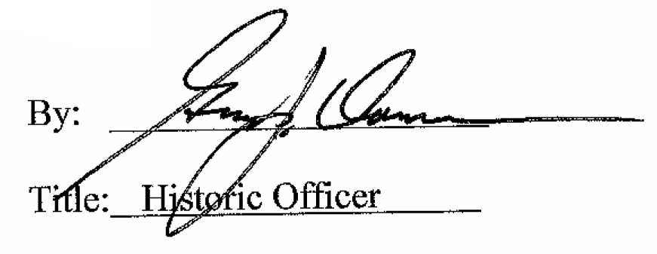

Date of Meeting: May 3, 2017

